Hosting of the 2018 LINK OF CINE-ASIA
- Sunday 7th- Tuesday 9th October, for 3 days at The Haeundae Paradise Hotel, Busan
- Program consisting of sessions such as ‘Forum & Pitching’, ‘BIZ Matching’,
‘Networking & Lounge’
- 3 forum sessions and 6 project pitching events
- 49 BIZ Matching projects, 32 investors and producers and 21 film commissions and institutions to participate

Hosted by the Busan Film Commission, the 2018 LINK OF CINE-ASIA (Asian Film Forum & Business Showcase) will be held for 3 days at the Haeundae Paradise Hotel, Busan from October 7 (Sun) to 9 (Tue).

LINK OF CINE-ASIA, which is being held for the third year, consists of Forum sessions for discussing issues related to film and video industries, new technologies for film, fostering exchanges between Asian regions and filming support as well as Project Pitching introducing feature films, web toons, web dramas, VR contents and such various transmedia genre projects in Asian countries. In addition, BIZ Matching arranges meetings between parties who are interested in international co-production and overseas location shooting (49 projects), investment and production companies (32 companies) and film commissions and institutions (21 institutions). Meanwhile, various events such as Networking events and diversely-themed Lounges will also be available.

It is notable that this year will see a lot of planning and development program projects carried out by organizations and groups. The five projects selected by SEAFIC (Southeast Asian Fiction Film Lab) and winners of the ‘G-Cinema Scenario Planning and Development Support’ which is jointly run by the Gyeonggi Film Commission and the Directors Guild of Korea, web toons supported by the Korea Manhwa Contents Agency, and projects fostered by Busan Film Commission and the Busan Asian Film School as well as individual projects are all taking part in the BIZ Matching project which will encourage planning, development, investment, production meetings and shooting. Furthermore, it will provide opportunities for introducing works through project pitching in order to encourage the possibility of filming.

Following on from last year, this year’s forum will consist of three sessions. The Large Format in Cinema Technology Session will focus on the large-format camera and the full-frame format, which are receiving attention in the film industry worldwide. The Rising ASIA Session will contain information on filming locations in Primorye, Russia (Primorsky Kray), where Vladivostok is located, Cambodia, which has world cultural heritage and natural coastal beauty, and also Myanmar, a representative Buddhist country in Asia. The One ASIA workforce training workshop will be held to the theme of fostering local manpower for overseas production shooting. In addition, AFCNet, a network of 59 members from 18 Asian countries, will also hold a regular general meeting this year which aims to cover new membership approval and joint marketing issues.

A lounge available for use to all participants will be located on the second floor of the event hall. In the Busan Lounge participants can experience interactive images developed by ETRI. In the AFCNet Lounge, which is jointly run with the ASEAN Culture House, participants can receive information on filming sites in Asia and film commissions. The Gangwon Film Commission will show a lounge of Peace Gangwon - "Yes, Gangwon!!" which is a theme of Gangwon Province. Gangwon Province, the place where its popularity has been largely due to its beautiful landscapes, 2018 Pyeong Chang Olympics, and filming sites will have a meaningful time to promote the launch of the first PIPFF(Pyeongchang International Peace Film Festival).
Lastly, every evening during the period will see a range of events being held, starting with the opening reception for LINK OF CINE-ASIA and also including the BMBD networking party, ARRI party, AFCNet Global Networking Party held jointly with the PGK (Producers Guild of Korea) and NAPNet (New Asia Producers Network)’s Night.
[Appendix] 2018 LINK OF CINE-ASIA Schedule.
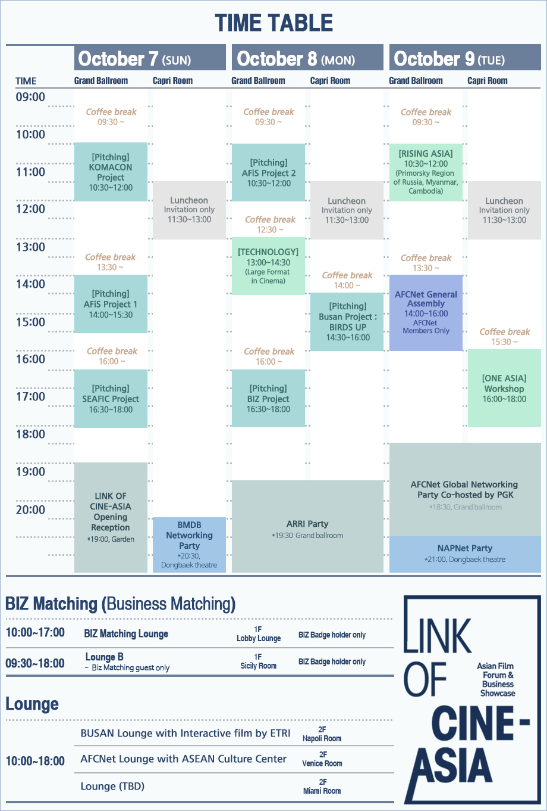
※ This schedule may be subject to change

